NEWSLETTERS
The Trump problem in Massachusetts
Three writers on Massachusetts’ Republican candidates for governor and what obstacles they face along the road to November.
By Abdallah Fayyad, Joan Vennochi and Charles Chieppo Globe Staff and Globe Columnist, Updated April 29, 2026, 2:01 p.m.
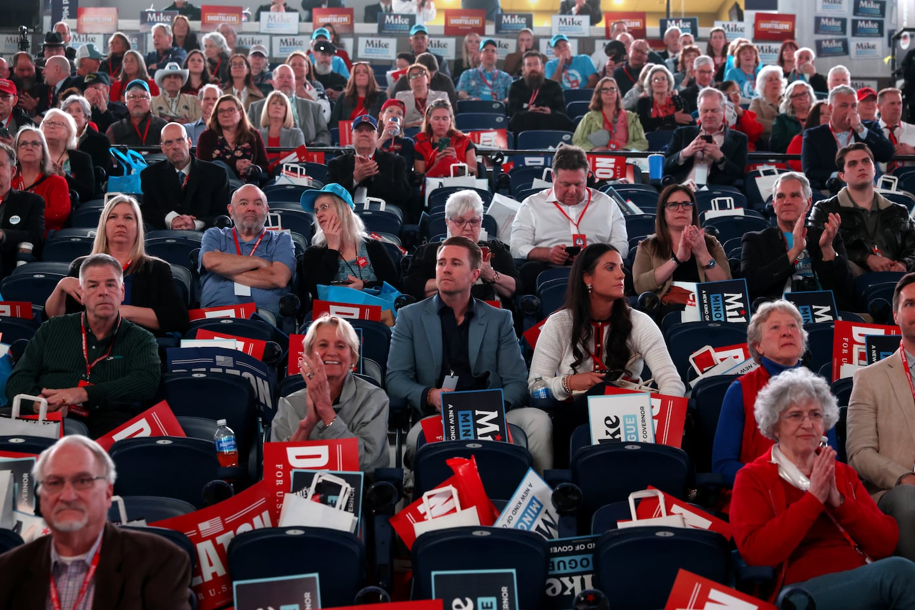Delegates at the Massachusetts GOP convention on April 25.Jonathan Wiggs/Globe Staff
Republican delegates to the state GOP convention last weekend overwhelmingly endorsed Mike Minogue, an Army veteran, med-tech businessman, and political novice to be the party’s favored candidate to run against Governor Maura Healey in November. Minogue will next face the second-place finisher at the convention, Brian Shortsleeve, a veteran of Charlie Baker’s administration, in a September primary.
Whoever wins that contest, the question of whether he can mount a serious challenge to Healey remains very much in doubt — even if the governor’s standing in polls suggests that she is potentially vulnerable.
We asked three writers to tell us more about who the Republican candidates are, and what obstacles they face along the road to November. Here’s what they said.

Minogue would be wise to focus on state politics, not Trump policies
By Abdallah Fayyad
Moderate Republicans have become a rare breed in Massachusetts. President Trump and his politics loom large in the state, and his polarizing actions have only strengthened the Democrats’ grip on power. Since former governor Charlie Baker, a Republican, left office, the GOP has been effectively locked out of state government, and there’s little reason to believe that’s going to change anytime soon.
The Massachusetts Republican Party has now endorsed Mike Minogue, a former biotech executive, as its candidate for governor. Mike Kennealy, who served as the secretary of housing and economic development under Baker, was viewed as the more moderate candidate. But the state party resoundingly rejected him: 70 percent of the party’s delegates at the nominating convention chose Minogue over Kennealy and Brian Shortsleeve, a former MBTA general manager. While Shortsleeve will still be on the primary ballot in September, Kennealy was eliminated, since he did not clear the 15 percent threshold required to make the ballot.
Minogue, who has poured some $12.5 million into his campaign, is a prolific Republican donor, and he even hosted Vice President JD Vance at a fund-raiser last year. Regardless of how much he tries to court moderate voters across the state, it will be extremely difficult for him to meaningfully distance himself from Trump between now and November.
It’s not just a matter of optics. Minogue has wasted no time making his priorities known, and he’s aligned himself with several key Trump policies, promising to get “criminal illegal immigrants off our streets” and declaring that “girls need fair and safe sports.” That sort of politics may have helped Trump win the presidency in 2024, but it won’t help Minogue in a state where Trump got only 36 percent of the vote.
If Minogue wants to have any shot at all at winning the governor’s race, he would be wise to just focus on state politics. He drew raucous applause from the convention crowd, for example, when he pledged that he would repeal the MBTA Communities Act, which encourages building denser and transit-oriented housing and was signed into law by Baker. While I think that law is important in combating Massachusetts’ housing crisis, it’s proved to be controversial and has generated substantial backlash, even in liberal parts of the state.
A talented politician could use issues like that to make Governor Maura Healey, a Democrat, worry. But as long as the Massachusetts GOP keeps aligning itself with Trump — and as long as Trump is still president — Healey will cruise to reelection without breaking a sweat.
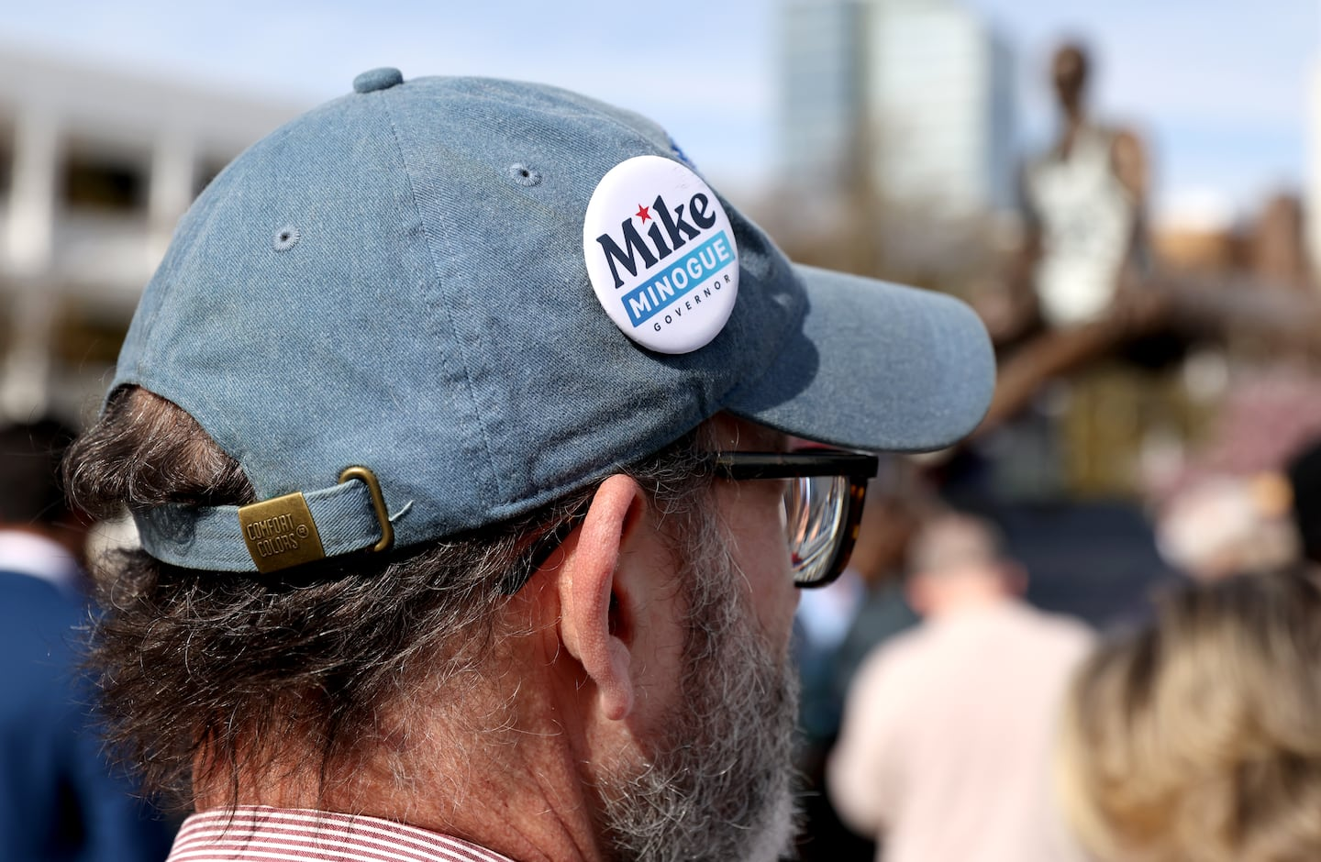A Mike Minogue supporter outside the Massachusetts GOP convention on April 25. Jonathan Wiggs/Globe Staff

Mike Minogue’s kiss of death
By Joan Vennochi
Mike Minogue made his money and mark in business selling pumps for artificial hearts.
Now, as the Massachusetts Republican Party’s endorsed candidate for governor, he must win over enough voters’ hearts to defeat Governor Maura Healey, a Democrat.
That’s a tough sell for Minogue, who last year hosted Vice President JD Vance at a fund-raiser and donated to President Trump’s re-election bid and the Republican National Committee.
In a recent WBUR profile, the former head of Abiomed also said, “I am pro-life. I support a culture of compassion and life. I spent a career in the medical device industry helping to save lives, young and old, and I also think that we can do more to help people in a time of crisis.”
Nicely put, but still a kiss of death with the state’s liberal voters.
Within the tiny universe of Republican activists who attended last weekend’s convention, Minogue had four advantages: private-sector success, a military background (he’s a West Point graduate and served in Iraq), no other big races to be voted on, and lots of his own money to spend on organizing.
Of the three candidates seeking the party’s endorsement, Minogue was also the most politically conservative. But what made him attractive to the Trumpian base that now controls the Massachusetts GOP makes him a very challenging sell as a statewide candidate.
Out of the state’s 5.5 million registered voters, only 420,000 are Republicans. To have any chance at beating Healey, he has to do what every successful Republican gubernatorial candidate has done — tap into the 3.25 million voters who are registered as unenrolled or independent, and who make up the largest voter pool.
To woo them, Minogue will likely try to focus on management and fiscal issues. According to a recent UNH Survey Center poll, 49 percent of Massachusetts residents approve of Healey’s handling of the job, 45 percent disapprove, and 6 percent don’t know or are undecided. She gets her worst ratings on her handling of taxes, the economy, housing, and the cost of living.
While that might seem like an opening, Massachusetts Democrats will surely do everything they can to hang Trump around Minogue’s neck. He also has a primary fight with Brian Shortsleeve, the other Republican who won enough votes at the convention to get on the ballot.
That GOP primary fight could push the candidates even further to the right. If it does, the GOP can forget about beating Healey.
Even if it doesn’t, I still think the woebegone Red Sox have a better chance at winning the World Series than any Massachusetts Republican has at winning the governor’s office.

The issues that could sink Healey (if only Trump weren’t president)
By Charles Chieppo
The Republican convention that endorsed Mike Minogue to be the GOP standard-bearer for governor was a low-turnout affair, as is too often the case with Republican politics in Massachusetts.
At the convention, only about 1,800 out of more than 4,000 eligible delegates cast a vote. Next comes the primary on Sept. 1, when Minogue will face venture capitalist and former MBTA chief Brian Shortsleeve, who finished a distant second at the convention. Chances are good that that race will be closer.
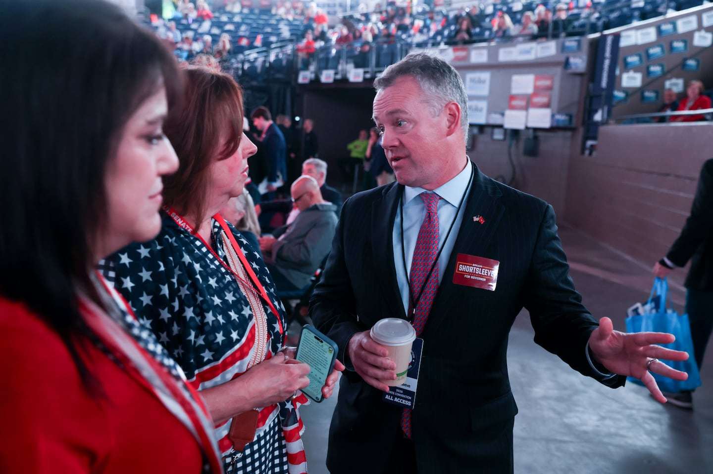Gubernatorial candidate Brian Shortsleeve at the Massachusetts GOP convention on April 25. Jonathan Wiggs/Globe Staff
Like recent Republican governors in Massachusetts, both candidates promise to make the Commonwealth more affordable and business-friendly, and both pledge to control state spending. But unlike their predecessors, they also warn about the high cost of illegal immigration. Neither is critical of the Republican president. And while they share many positions — both running primarily on pocketbook issues — Minogue calls himself a “born-again Catholic” and is anti-abortion, while Shortsleeve is largely silent on the issue.
History teaches us that the eventual nominee is likely to move to the center during the general election. But does that mean the eventual Republican nominee will at some point criticize President Trump? Hard to say.
The two candidates have no shortage of ammunition to use against the almost certain Democratic candidate, Governor Maura Healey. For a decade beginning in 2010, Massachusetts had the second highest rate of business formation among the states, but between January 2020 and September 2024, we had the lowest net rate of any state. Today Massachusetts is one of just four states to have fewer private-sector jobs than in 2020. Outmigration has risen dramatically since 2012.
Housing, health care, and energy costs are through the roof, and taxes are high compared to other states. A key reason is that Massachusetts spends too much. Since 2010, median household income has grown by 13 percent, but real state spending is up 28 percent.
Healey has taken steps to address the housing shortage by limiting the power of municipalities to stop development and making surplus state land available for housing. But she has shown little stomach for challenging her party and its interest groups by reining in state government and cutting high costs that are eroding the Commonwealth’s competitiveness.
As is usually true, the case against one-party government is strong. Nonetheless, there’s a simple reason why the outlook remains grim for Massachusetts Republicans this November: Trump.
Trump’s tariffs have exacerbated the affordability problem he pledged to fix. Rather than addressing the nearly $38 trillion national debt that looms over our children, the United States spends $2 billion a day fighting Iran – precisely the kind of “forever war” he promised to avoid.
Many Trump policies hit Massachusetts especially hard. His war on immigration extends to highly educated immigrants on whom Massachusetts depends to make up for losses to outmigration, and cuts to university and medical research strike at the heart of the state economy.
Absent Trump, this fall’s election might be a real opportunity for the Massachusetts Republican Party. But anti-Trump fervor is likely to drive turnout among Democrats and independents eager to register their disdain.
Charles Chieppo is the principal of Chieppo Strategies, a public policy communication firm, and a senior fellow at Pioneer Institute, a Boston-based public policy think tank.
This is an excerpt from Globe Opinion’s weekly politics newsletter Right, Left, and Center. Sign up here to get it delivered directly to your inbox.

